Preparation of Cooling System
Install the liquid helium transfer line on cryostat and seal it with o-ring nuts (which are installed on cryostat - see figure below).
Blind the liquid helium transfer line tip with filter by using silicone hose (putting a hose on a filter).
There are two ball valves on the cryostat: DN 16KF and DN 25KF and the pre-vacuum pump is plugged in to them.
Immerse few rolls of pump hose into a water tank. Water will heat the pumped helium to prevent damage to the pre-vacuum pump.
There is a tee between DN 25KF and the cryostat, with valve installed in order to shut off the line of helium gas. Helium gas under the pressure of ca 0.5 [bar] is used for cleaning and aeration of cryostat and liquid helium transfer line.
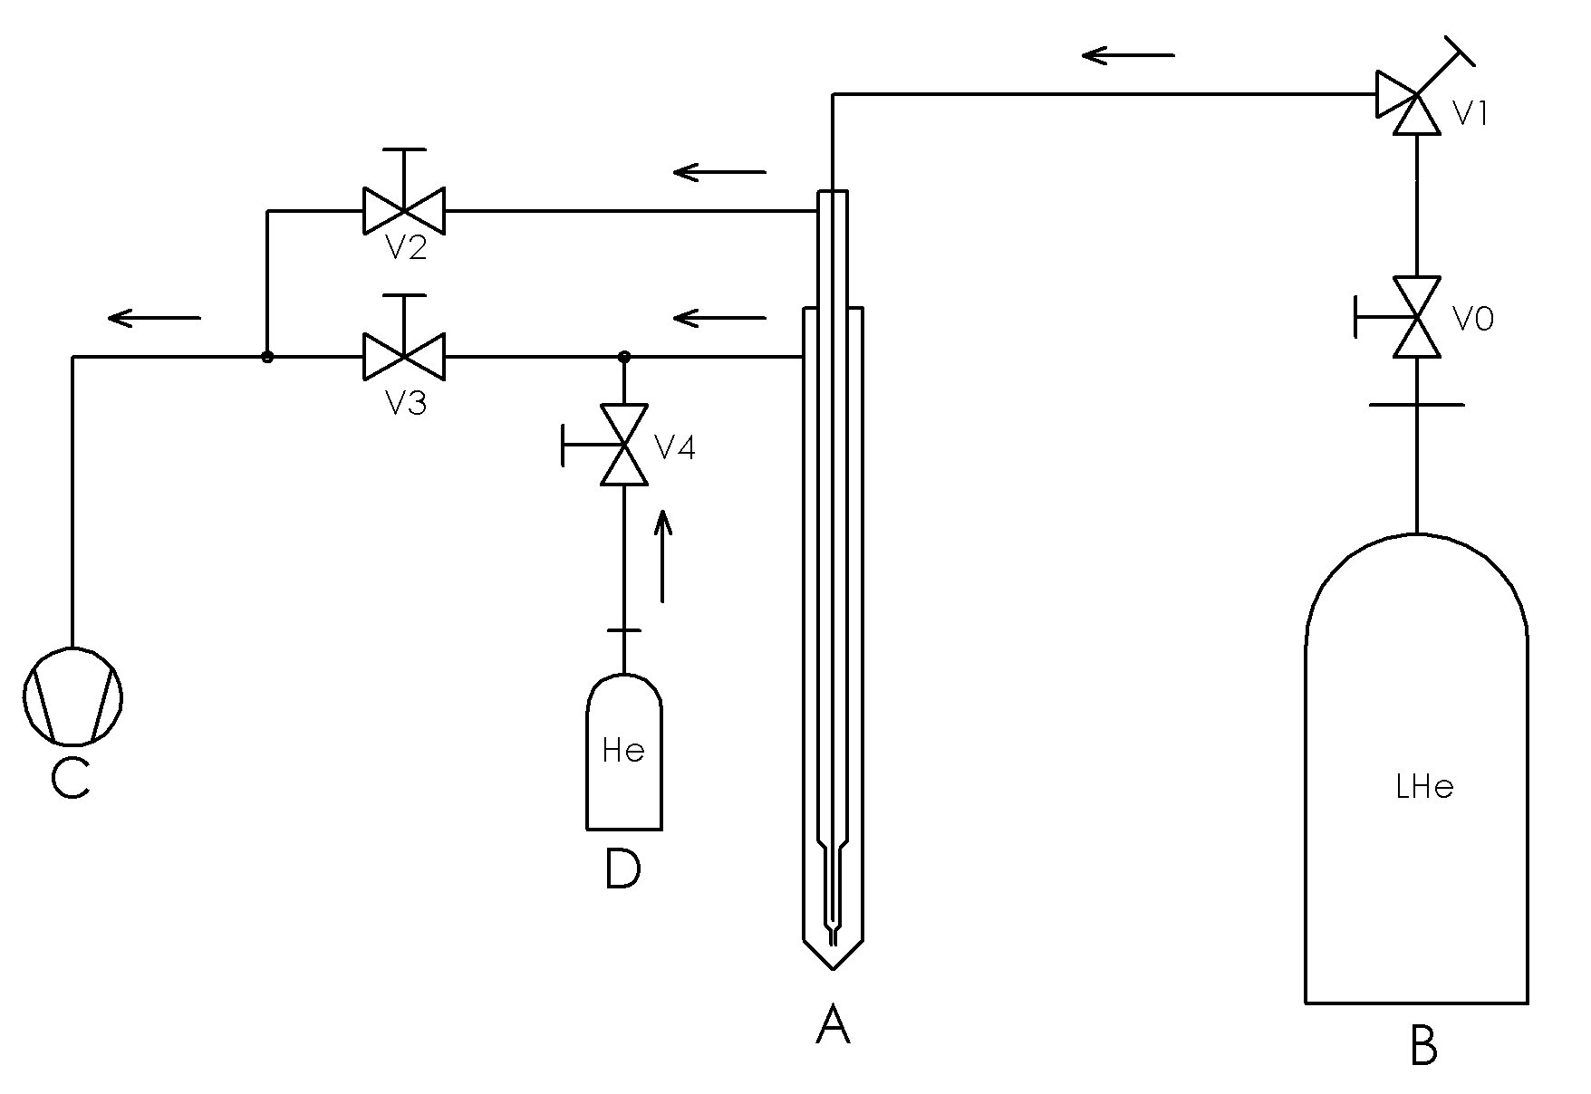
A – Cryostat; B – Liquid helium tank (Dewar); C – Fore vacuum pump; D – Cylinder with helium gas; V0 – valve; V1 – control valve; V2 – DN 16KF ball valve; V3 – DN 25KF ball valve;
V4 – gas dosing valve;
- Liquid helium cooling-scheme

Drying the Liquid helium transfer line
Drying of the liquid helium transfer line should be done before insertion to the liquid helium tank.
- The valve V1 on the liquid helium transfer line and valves V2 and V3 should be entirely opened.
- The valve V4 for shutting off a helium gas remains closed.
- Turn on the pre-vacuum pump and pump the liquid helium transfer line for at least 3 minutes.
- Close the both V2 and V3 valves.
- Open the valve V4 to insert a helium gas from the cylinder to the system.
- Close the valve V4 and open the ball valves V2 and V3 after about 3 minutes.
- Repeat all steps at least three times.

Do not turn off the pre-vacuum pump after the process of cleaning!

Installation of the Liquid helium transfer line on the Dewar Vessel
- After cleaning process, close the pump valves V2 and V3 and then open the valve V4 to reach overpressure of ca 0.5 [bar] on the liquid helium transfer line.
- Meanwhile, open the main valve V0 on the Dewar vessel and release the overflow of helium gas to get the pressure balance in it. It helps to get rid of the gas cushion in Dewar chamber.
- Remove the plug from the liquid helium transfer line's tip.
- Loosen the sealing nut on the cryostat.
Hold the liquid helium transfer line during loosening the sealing nut in order to protect it from falling out of the cryostat, because overpressure will try to push the liquid helium transfer line out.
- Eject the liquid helium transfer line from the cryostat to a height which allows the insertion of the tip to the Dewar vessel.
- Insert the tip carefully to the Dewar with insertion of liquid helium transfer line to the cryostat at the same time.
- Tighten the seal nuts on the Dewar vessel and cryostat.
- After insertion of liquid helium transfer line tip to the Dewar vessel, close the valve V4 that inserts a helium gas and open the ball valves V2 and V3.
- If the nut on the cryostat will frost strongly, then it should be heated using e.g. a heat gun. It protects from damages of the o-ring during tightening the nut because rubber becomes hard and brittle at low temperatures.
Take special care during installation of the liquid helium transfer line. Always wear protective clothes, thermal gloves and safety goggles.

Cooling
- After installation of liquid helium transfer line (see the section above), the valve V4 (this one which inserts helium gas) is closed and the pump valves V2 and V3 are opened.
- The valve V1 on the liquid helium transfer line should be entirely opened.
- When a top part of the cryostat starts to frost, close the ball valve V2 (DN 16KF) in 80 percents (it should be slightly opened). The valve V2 (DN 16KF) should be closed before frosting.
- The ball valve V3 (DN 25KF) is opened all the time of cooling process.
- In this moment the cooling of the cryostat tip begins. Using the copper plates, the cooling of the Station, shield and Sample Holder starts too.
- Close entirely the valve V1 on the liquid helium transfer line when desired temperature is achieved and then open it by one rotation.

Optimizing a Helium Consumption in the Cooling Process
- To minimize a helium consumption, perform the following steps:
- When a temperature on the cryostat tip is stabilized, close slightly the valve V1 on the liquid helium transfer line, looking at temperature indication on the monitor at the same time.
- The temperature will increase a little, then will decrease and stabilize.
- Repeat these steps until a decrease of the temperature is not noticeable (the temperature can only increase).
- Return to the settings of the valve V1 described in points 1÷2 guarantees a minimum helium consumption in a given temperature.
Note:
- Thermocoax serves only for stabilizing the negative temperatures!
- You can not heat thermocoax because of the use of silicon diodes, which can be easily damaged.

